**EC2 INTRODUCTION**

It is server based service.

EC2 🡺Elastic compute cloud(Regional service).

**IAAS**

Renting virtual machines

Storing data on virtual drives (EBS)

Distributing load across machines (ELB)

Scaling the services using an auto-scaling group (ASG)

1) OS

2) RAM

3) Storage

4) KeyPair

5) Security

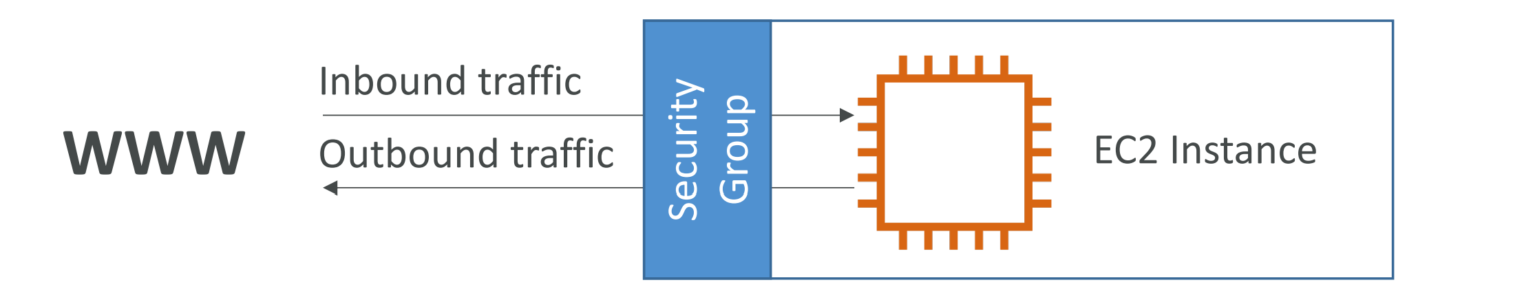

Security groups rules can reference by IP or by security group.

**Some basic ports you should know :**

22 🡺SSH

80 🡺 HTTP

443 🡺HTTPS